# Quick Use

## Quick Operation

### Product Structure Drawings

The structure of the meeting TV camera is shown in Figure 1-1 and Figure 1-2.

Front view

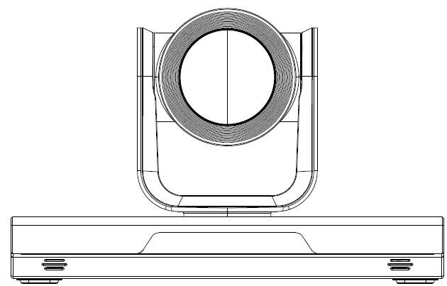

Rear view

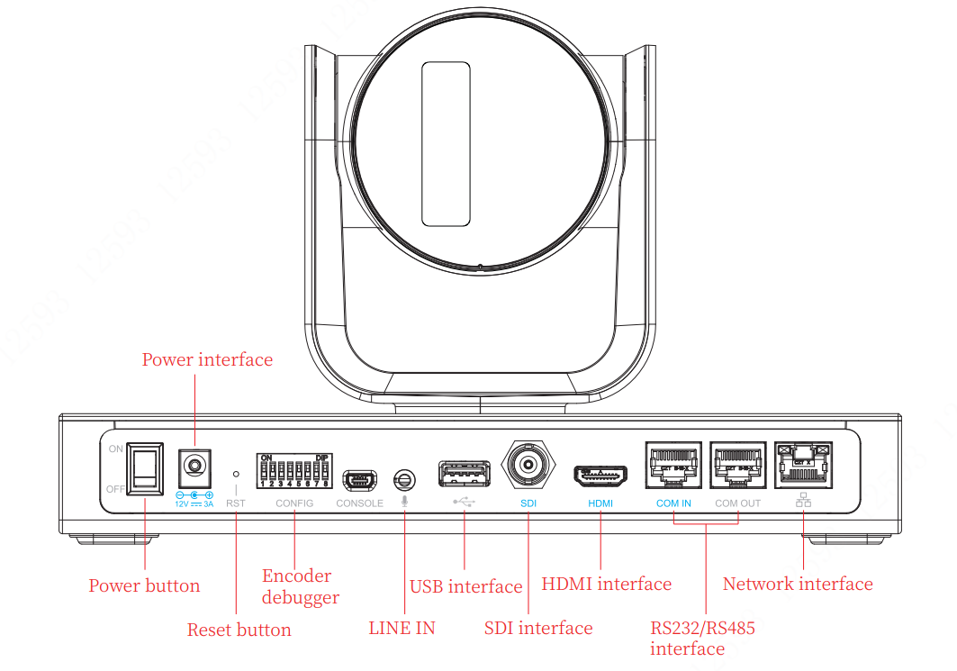

### Product Networking Graph

The networking of the meeting camera is shown in Figure 1-3.

Networking graph

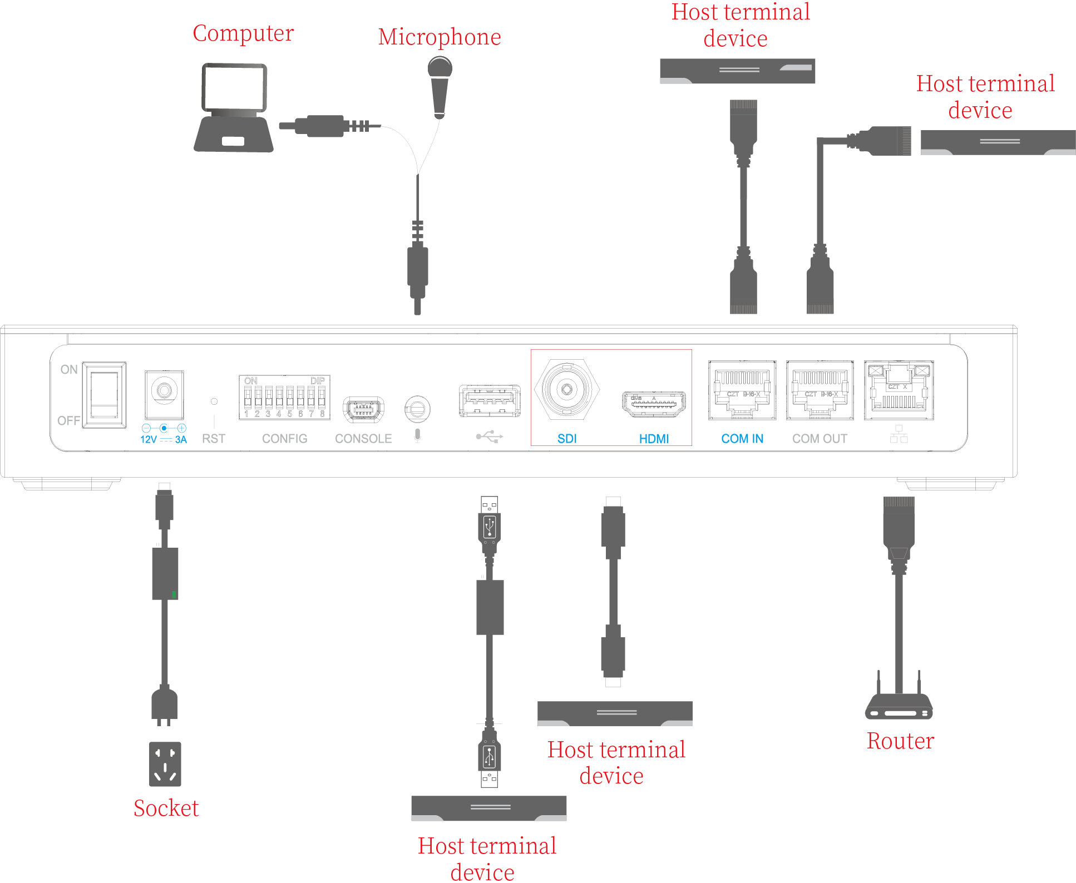

### Quick Use

1. The wiring is shown in the figure. Press the power switch after correct wiring.
2. The camera starts self-test. The PTZ rotates first and then the zoom-in and zoom-out rates of the zoom lens are checked after the rotation stops.
3. After the self-test is completed, the camera stops in the middle position. The indicator on the display in front of the camera shows blue, indicating normal operation. The camera IP address is displayed as well.

Wiring diagram

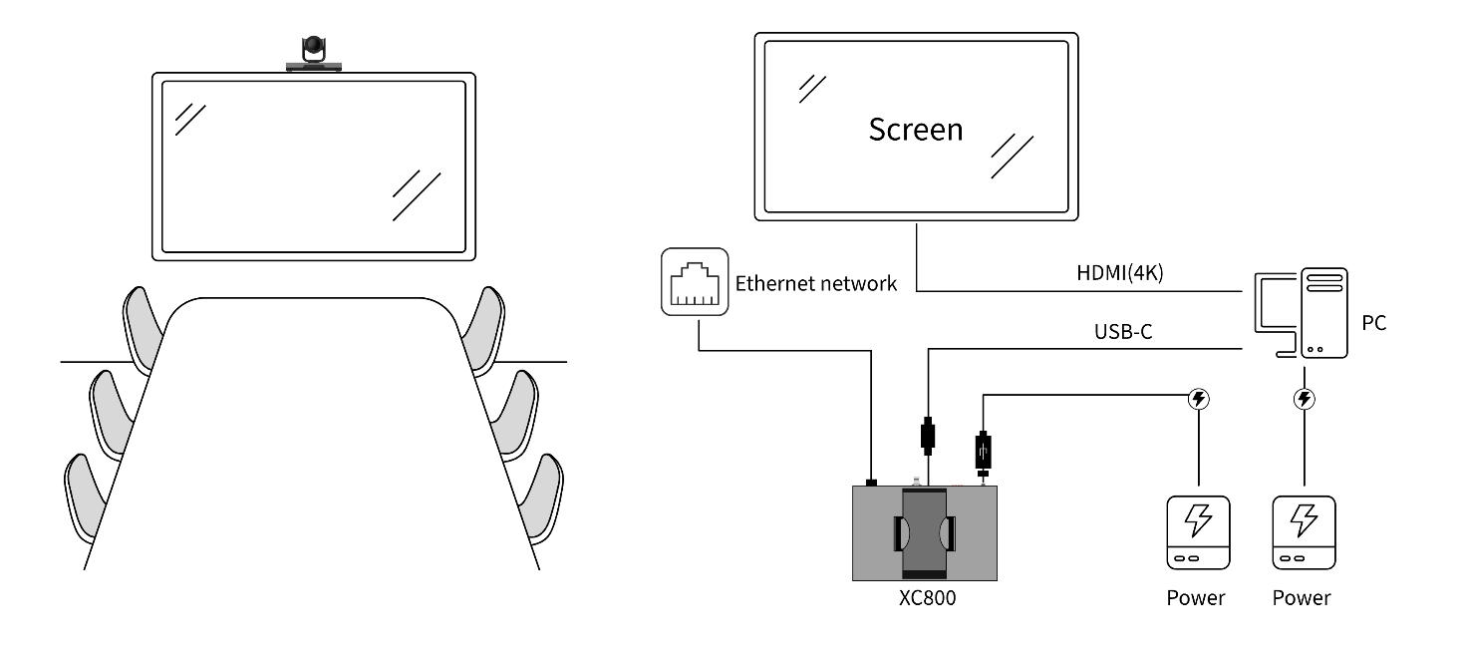

## Product List

Before mounting, verify items in the package according to Table 1-1.

List of Items

| No. | Name | Illustration | Quantity |
| --- | --- | --- | --- |
| 1 | USB Camera |  | 1 set |
| 2 | Remote controller |  | 1 piece |
| 3 | Holder |  | 1 set |
| 4 | Power adapter |  | 1 piece |
| 5 | Power wire |  | 1 piece |
| 6 | Network wire |  | 1 piece |
| 7 | HDMI wire |  | 1 piece |
| 8 | USB3.0 connecting wire |  | 1 piece |
| 9 | Screw pack |  | 1 pack |
| 10 | M3×8 cross recess countersunk head flat tail machine screw |  | 4 pcs |
| 11 | Manual |  | 1 copy |

## Mounting of Product

The meeting TV camera can be mounted in three ways: Hanging mounting, wall mounting, and ceiling mounting.

### Hanging mounting

If the display thickness is 170 mm or less, hanging mounting can be used, meaning that the camera will be hung onto the display. The specific mounting steps are shown in Figure 1-5.

Hanging mounting

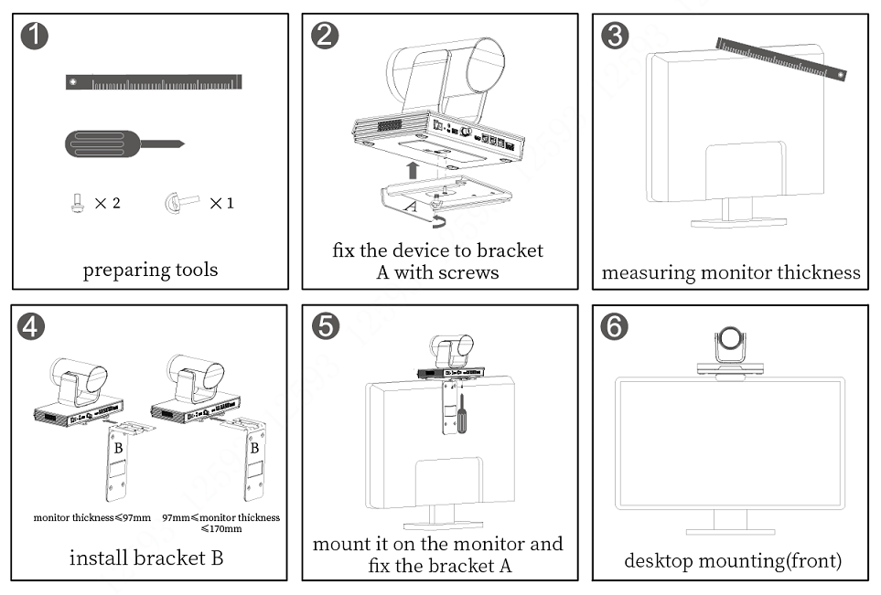

### Wall mounting

If the display thickness is over 170 mm, or if the display needs to be mounted onto the wall, wall mounting can be selected. The specific mounting steps are shown in Figure 1-6.

Wall mounting

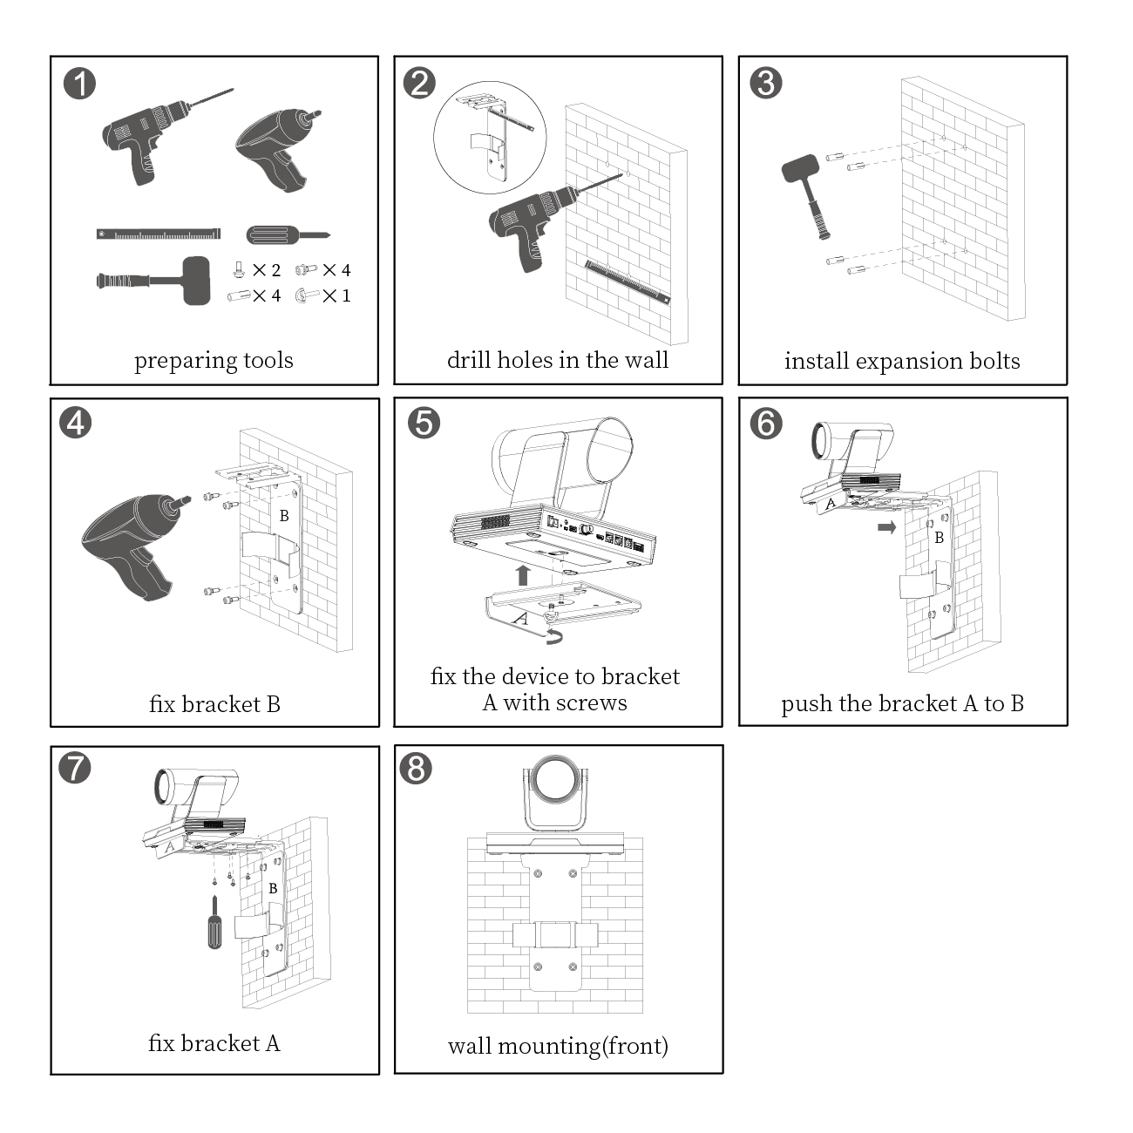

### Ceiling mounting

 Notes

The holders for ceiling mounting are not standard components and shall be purchased additionally.

If hanging mounting or wall mounting is not feasible, ceiling mounting can be an option. The specific mounting steps are shown in Figure 1-7.

Ceiling mounting

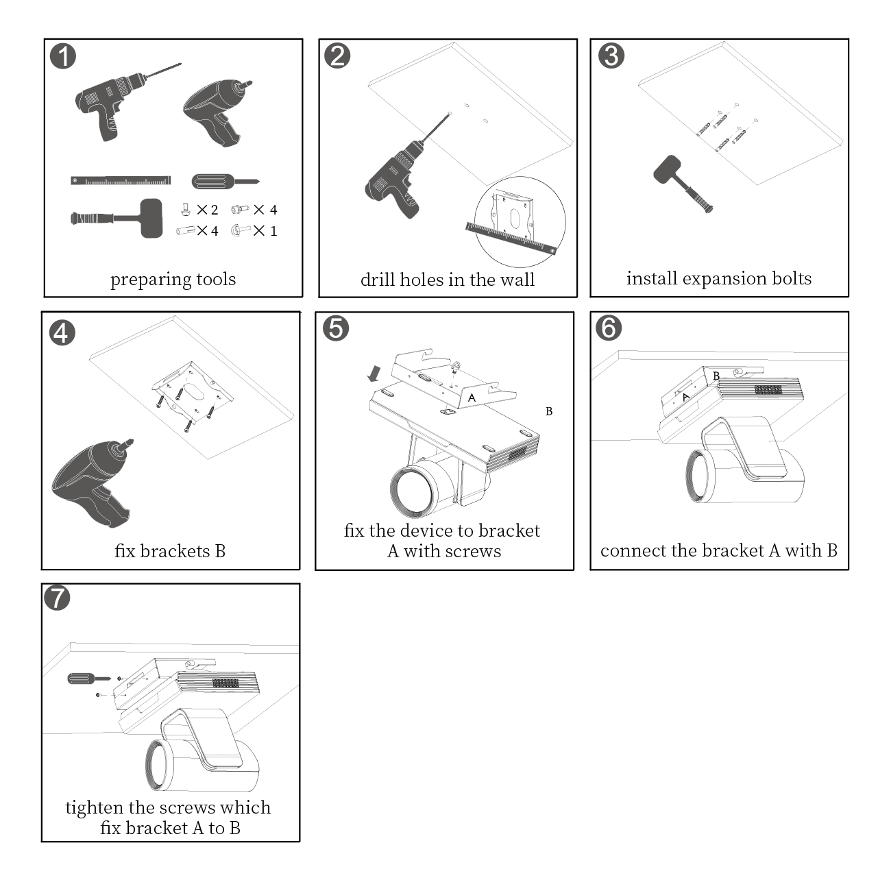

## Remote Controller and Encoding Debugger

### Remote controller

|  |  |  |  |  |  |  |  |  |  |  |  |  |  |  |  |  |  |  |  |  |  |  |  |  |  |  |  |  |  |  |  |  |  |  |  |  |  |  |  |
| --- | --- | --- | --- | --- | --- | --- | --- | --- | --- | --- | --- | --- | --- | --- | --- | --- | --- | --- | --- | --- | --- | --- | --- | --- | --- | --- | --- | --- | --- | --- | --- | --- | --- | --- | --- | --- | --- | --- | --- |
| Remote controller | Buttons   | No. | Icon | Meaning | | --- | --- | --- | | 1 |  | Status indicator. | | 2 |  | Reserved. | |  | Reserved. | |  | Camera focus adjustment button. | |  | Menu direction selection button, camera direction adjustment button.  Up, down, left, right buttons. | |  | OK button. | |  | Reserved. | |  | Reserved. | |  | Reserved. | |  | Reserved. | | 3 |  | "Return" button. When this button is pressed, the menu returns to the previous interface or operation. | |  | Menu button. When this button is pressed, the main menu appears. | |  | Reserved. | |  | Reserved. | |  | On/Off (The meeting hanging-up icon is reserved). | |  | Used to enter numbers, Chinese/English characters, and symbols. | |

### Encoding debugger

Encoding debugger

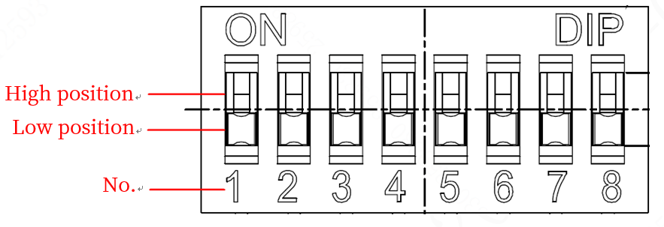

Parameter description

| No. | Settings description |
| --- | --- |
| 1 | Retain |
| 2 |
| 3 |
| 4 | Switching of communication Protocol.   * High position: RS232 Protocol. * Low position: RS485 half-duplex Protocol / RS422 Protocol. |
| 5 | Switching between RS485 half-duplex Protocol and RS422 full-duplex Protocol.   * High position: RS485 half-duplex Protocol. * Low position: RS422 full-duplex Protocol. |
| 6 | Binary address code. Example: To set the device address to 6, both 6 and 7 shall be switched to the high position.  Notes  The device address cannot be 0, and supports at most 7 coded addresses. |
| 7 |
| 8 |